E-PORTFOLIO DEVELOPMENT FRAMEWORK
A Guidance Document for Second-Year Management Students
Building E-Portfolios That Strengthen Recruitment Prospects
Career Readiness Series | Marketing Area

Why Your E-Portfolio Matters
In placement interviews and PPO conversion rounds, recruiters increasingly ask for a portfolio link alongside your CV. A resume tells a recruiter what you claim; an e-portfolio shows whether it is true. This framework translates that expectation into eleven concrete, non-negotiable standards, organised into three clusters, so that you know exactly what to build, why it matters to a recruiter, and how to execute it well.

The Framework at a Glance

Cluster A — Establish Your Identity
1 | Clear Professional Positioning — Who You Are, Your Academic Credentials, and the Roles You Are Targeting
2 | Professional Photo & Contact Details
3 | Updated Resume, LinkedIn & Certification Links

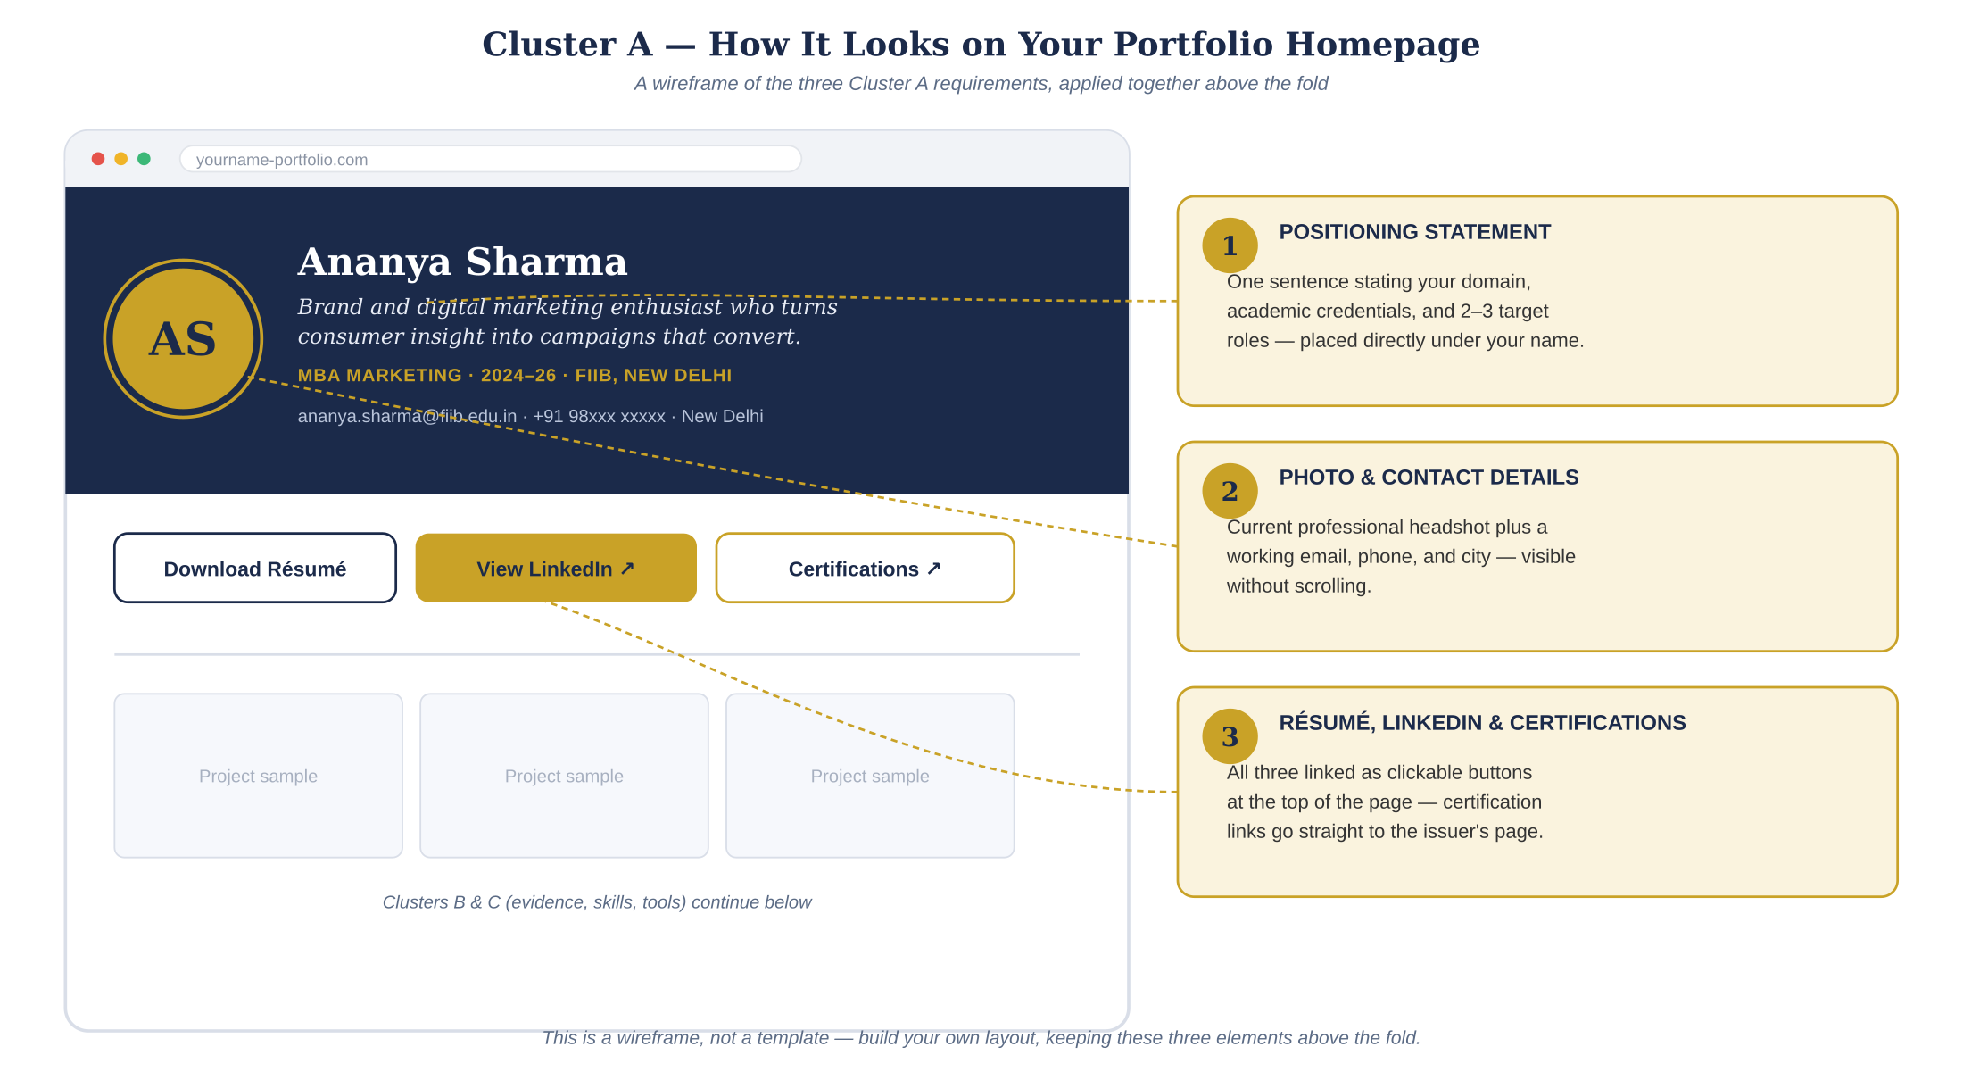
Figure 1 — Cluster A translated into an actual portfolio homepage layout.

Cluster B — Prove Your Capability
4 | 3–5 Strong Work Samples / Projects, with Live Working Samples
5 | Show Evidence, Not Just Claims
6 | Clearly Mention Your Role & Contribution in Every Project
7 | Quantify Outcomes and/or Impact Wherever Genuinely Possible

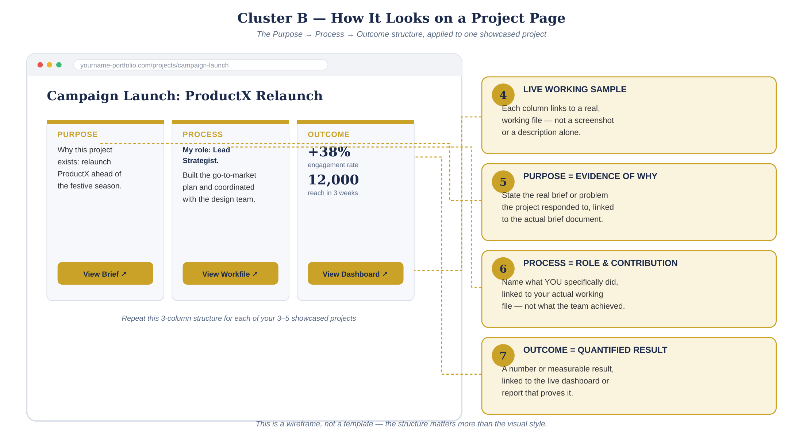
Figure 2 — Cluster B translated into an actual project page layout.

Cluster C — Present Yourself Credibly
8 | Relevant Skills Only — No Inflated Proficiency
9 | Relevant Tools Only — List What You Can Actually Use
10 | Clean, Consistent & Error-Free Presentation
11 | All Links Must Work — Portfolio Must Be Easy to Navigate

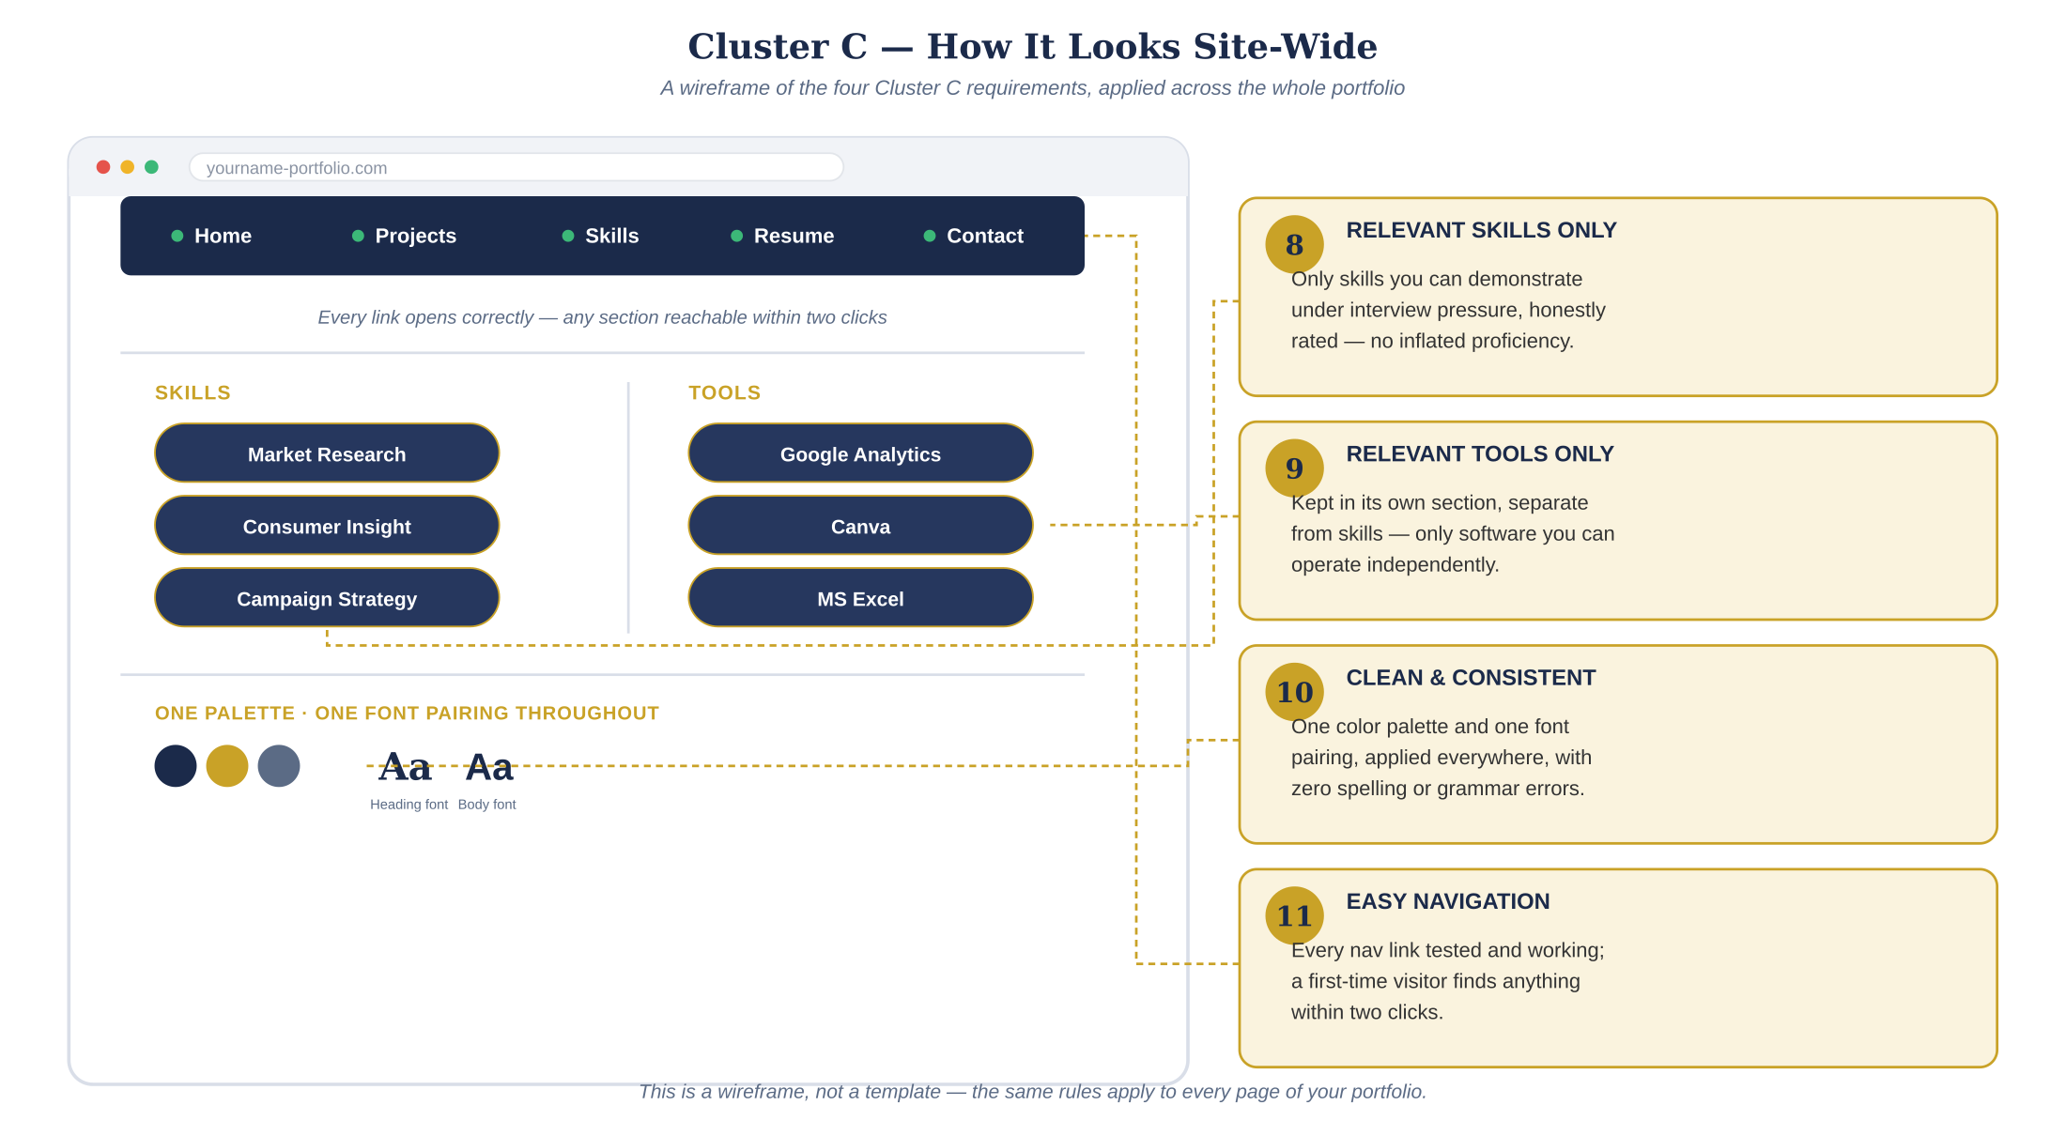
Figure 3 — Cluster C translated into site-wide navigation, skills, and tools sections.

Detailed Guidance
Each standard below follows the same structure: what it means, why recruiters care, how to execute it, and the most common mistake to avoid.

Cluster A — Establish Your Identity

1. Clear Professional Positioning — Who You Are, Your Academic Credentials, and the Roles You Are Targeting
WHAT IT MEANS: A one-line professional identity statement combining your specialization, academic credentials, and the 2–3 roles you are targeting.
WHY RECRUITERS CARE: Recruiters scan hundreds of portfolios; a fuzzy identity gets skipped. A sharp positioning line tells them instantly whether you fit their open role.
HOW TO EXECUTE: Use the formula Domain + Value + Edge — e.g., “Brand and digital marketing enthusiast who turns consumer insight into campaigns that convert, built on a foundation in market research.” State your degree, specialization, and batch year directly beneath it.
AVOID: Generic openers such as “dynamic and result-oriented individual” that could describe any student in your class.

2. Professional Photo & Contact Details
WHAT IT MEANS: A current, professional headshot plus a working email address, phone number, and city.
WHY RECRUITERS CARE: A portfolio without a face or reachable contact details reads as unfinished or abandoned.
HOW TO EXECUTE: Use a plain-background, shoulders-up photo in business or business-casual attire. Place contact details prominently, not buried in a footer.
AVOID: Casual selfies, group-photo crops, or outdated contact information.

3. Updated Resume, LinkedIn & Certification Links
WHAT IT MEANS: Your latest resume (as a PDF, not a photo or scan), a working LinkedIn profile URL, and links to any certifications you want recruiters to see — all linked directly from your portfolio homepage.
WHY RECRUITERS CARE: Your portfolio and resume must tell the same story; a mismatch in roles, dates, or claims raises credibility questions before an interview even starts. Unlinked certifications, similarly, are just a claim recruiters cannot verify.
HOW TO EXECUTE: Cross-check every claim in your resume against what your portfolio shows. Link each certification directly to its issuer page or verification URL (e.g., Coursera, Google, HubSpot), not just the certificate name in text. Update all three simultaneously whenever you add a new project, skill, or credential.
AVOID: Linking an old resume version, a LinkedIn profile with an incomplete experience section, or naming a certification without a working link to verify it.

Cluster B — Prove Your Capability
THE PROJECT DOCUMENTATION STANDARD
Purpose → Process → Outcome
Document every showcased project in three columns — Purpose (why the project existed), Process (what you did, and how), and Outcome (the measurable result) — each linked to its own working file: a brief, a working sheet, or a live dashboard. See Figure 2.

4. 3–5 Strong Work Samples / Projects, with Live Working Samples
WHAT IT MEANS: A curated set, not a dump, of your best work. Document each project in three columns — Purpose, Process, and Outcome — each linked to its own working file (a brief, a working sheet, a live dashboard, a deployed deck, or a demo video).
WHY RECRUITERS CARE: Quality signals judgment. Recruiters spend well under two minutes on a first pass, so five weak projects dilute your two strongest ones — and an unstructured project description makes them work to find what matters.
HOW TO EXECUTE: Select projects that map to the roles you named in Non-Negotiable 1. For each one, fill in Purpose (why the project existed), Process (what you did, linked to your working file), and Outcome (the result, linked to the live dashboard or report). Host files on Google Drive, Behance, or GitHub with sharing permissions set to “anyone with the link.”
AVOID: Broken or permission-locked links — the single fastest way to lose a recruiter's attention — or a project description that skips straight to the outcome without showing purpose or process.

5. Show Evidence, Not Just Claims
WHAT IT MEANS: Actual creative outputs — campaign decks, dashboards, reports, videos, mockups — not bullet points describing what you did.
WHY RECRUITERS CARE: Anyone can write “designed a marketing campaign.” Only evidence proves you can actually do it.
HOW TO EXECUTE: For every claim in your resume, ask: where is the artifact? If there isn't one, either build it or rephrase the claim to something you can evidence.
AVOID: Text-only project descriptions with no visual, file, or link attached.

6. Clearly Mention Your Role & Contribution in Every Project
WHAT IT MEANS: An explicit statement of what you personally did in group projects and internships, separate from what the team or organization achieved.
WHY RECRUITERS CARE: Group work is collective by nature; recruiters need to isolate your individual contribution to assess your capability.
HOW TO EXECUTE: Use a consistent format: “My role: [X]. My contribution: [specific task or output].” Be precise about scope — co-leading is different from leading.
AVOID: Team-level language (“we increased engagement by 40%”) with no indication of your specific part in it.

7. Quantify Outcomes and/or Impact Wherever Genuinely Possible
WHAT IT MEANS: Numbers, percentages, or measurable results attached to your work — and where numbers aren't available, a clear statement of qualitative impact.
WHY RECRUITERS CARE: Quantified outcomes are the fastest form of credibility; they let a recruiter compare your work at a glance.
HOW TO EXECUTE: Pull real metrics from your project — reach, engagement rate, cost saved, sample size, survey respondents. Where no metric exists, describe the impact honestly, e.g., “informed the college fest's sponsorship pitch.”
AVOID: Inventing or rounding up numbers you cannot explain if asked about them in an interview.

Cluster C — Present Yourself Credibly

8. Relevant Skills Only — No Inflated Proficiency
WHAT IT MEANS: A skills list restricted to what you can demonstrate under interview pressure, honestly rated.
WHY RECRUITERS CARE: Skill inflation is the most common reason candidates fail technical or case-based rounds after clearing the resume screen.
HOW TO EXECUTE: List only skills you have used in a real project shown elsewhere in the portfolio. Rate proficiency conservatively — “working knowledge” rather than “advanced,” unless it is genuinely advanced.
AVOID: Listing a skill only because it appears in a job description, without the ability to back it up.

9. Relevant Tools Only — List What You Can Actually Use
WHAT IT MEANS: Software and platforms — Excel, Canva, SPSS, Google Analytics, Power BI, and similar — that you can operate independently, kept as a distinct section from your skills.
WHY RECRUITERS CARE: Recruiters for analytics- or design-heavy roles often screen specifically for tool fluency; listing a tool you cannot use wastes an interview slot testing something you will fail.
HOW TO EXECUTE: Keep skills (what you can do) and tools (what you use to do it) in two separate sections. Only list a tool if you have used it in one of your showcased projects.
AVOID: Copy-pasting a generic tool list from a template or another student's portfolio.

10. Clean, Consistent & Error-Free Presentation
WHAT IT MEANS: Uniform fonts, colors, spacing, and formatting across every page and project, with zero spelling or grammar errors.
WHY RECRUITERS CARE: Presentation quality is itself a proxy for the attention to detail you would bring to a recruiter's brand or client work.
HOW TO EXECUTE: Pick one font pairing and one color palette and apply them throughout. Proofread out loud, then have a peer review the portfolio before you publish it.
AVOID: Mixing fonts or colors between projects, or leaving placeholder text such as “Lorem ipsum” in the final version.

11. All Links Must Work — Portfolio Must Be Easy to Navigate
WHAT IT MEANS: Every link — resume, LinkedIn, individual projects, contact — opens correctly, and a first-time visitor can find any section within two clicks.
WHY RECRUITERS CARE: A recruiter will not troubleshoot your portfolio for you. A dead link is simply a lost opportunity.
HOW TO EXECUTE: Test every link from a fresh, logged-out browser window immediately before sharing. Add a simple navigation menu or table of contents at the top of the portfolio.
AVOID: Sharing the portfolio link without a final end-to-end test pass.

The Golden Rule
THE GOLDEN RULE
Your e-portfolio should prove what your CV / resume claims.

Treat every line of your resume as a claim awaiting evidence. If your portfolio cannot substantiate it, either build the evidence or remove the claim.

Self-Audit Checklist
Run through this checklist before you share your portfolio link with any recruiter, placement coordinator, or on your resume.
☐ | Positioning statement names your domain, credentials, and 2–3 target roles
☐ | Professional photo and current contact details are visible on the homepage
☐ | Resume (PDF), LinkedIn link, and certification links are current and all work
☐ | 3–5 strong projects are showcased, each in Purpose / Process / Outcome columns
☐ | Each Purpose, Process, and Outcome column links to its own working file
☐ | Your individual role and contribution is stated separately from team/organisation outcomes
☐ | Outcomes and/or impact are quantified wherever genuinely possible
☐ | Skills listed are honestly rated and demonstrated in a showcased project
☐ | Tools listed are kept separate from skills, and you can operate each independently
☐ | Formatting (fonts, colors, spacing) is consistent and free of spelling or grammar errors
☐ | Every link, including certification links, has been tested in a fresh browser window
☐ | The portfolio, taken as a whole, proves — not just repeats — what your resume claims

